OFFICIAL COORDINATION REQUEST FOR
NON-ROUTINE OPERATIONS AND MAINTENANCE

COORDINATION TITLE- 20JDA04 MOC JDA STS Crane Replacement
COORDINATION DATE- 07 May 2020
PROJECT- John Day Dam
RESPONSE DATE- 21 May 2020 or FPOM meeting (12 May)

Description of the problem
The John Day Submerged Traveling Screens (STS) Crane is scheduled for replacement in the summer of 2021. The crane was manufactured in 1987 and has reached its end of life after a series of problems and emergency repairs. The main function of the STS Crane is to lift submerged traveling screens. This crane is located on the intake deck along with the intake and trash rake crane. The STS Crane shares the same runway and overhead electrification system as the intake crane.

The STS system is part of the juvenile bypass system and serves to keep downstream migrating endangered species fish out of the turbines. When the crane is not available for STS installation or removal and a screen went out of service, the JDA Project would be unable to generate hydroelectric power, or required to operate on a waiver and out of compliance with Biological Opinion and ESA statute requirements. There are no redundancies or backup equipment. Both the old and replacement STS cranes will be out of service for the month of August 2021 during the final demolition of the old crane.

Type of outage required – No outage required initially. The work will be performed with STS screens in place. If any damage occurs or maintenance is required on the submerged traveling screens, the corresponding unit will be shut down until the old crane is demolished and the new crane is once again able to access the screens.

Impact on facility operation (FPP deviations)
STS crane will not be available to move or perform maintenance on submerged traveling screens for the month of August 2021.

Impact on unit priority
None initially, but if any units are forced out of service due to STS issues, the unit priority may shift to support flow for fish purposes.
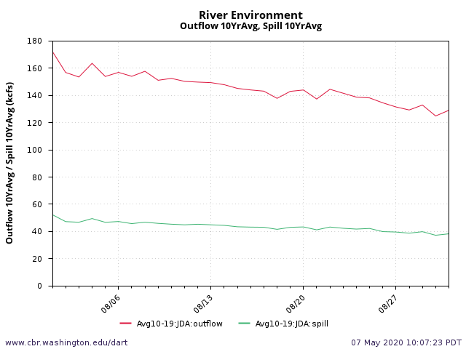

Impact on forebay/tailwater operation
No

Impact on spill
No

Dates of impacts/repairs -
August 2021

Length of time for repairs -
1 Month

Analysis of potential impacts to fish

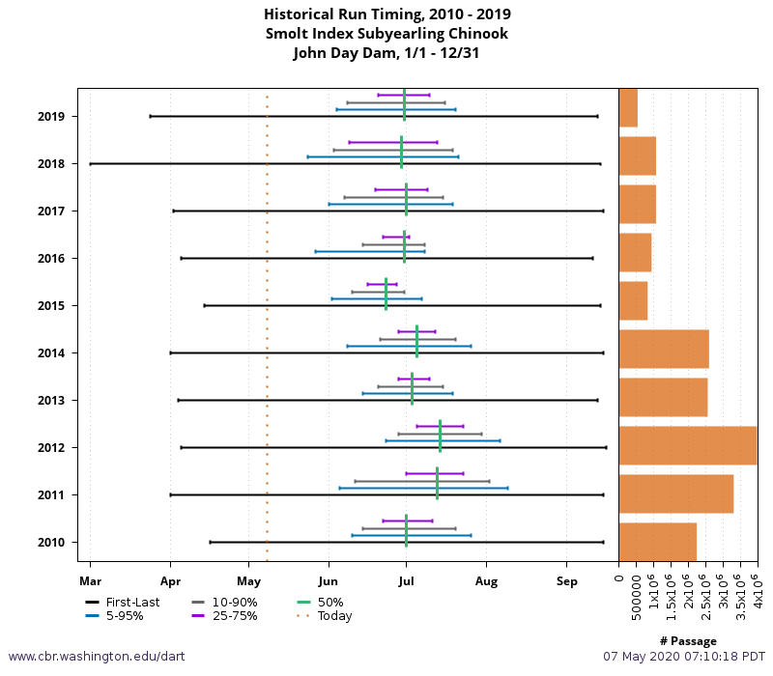
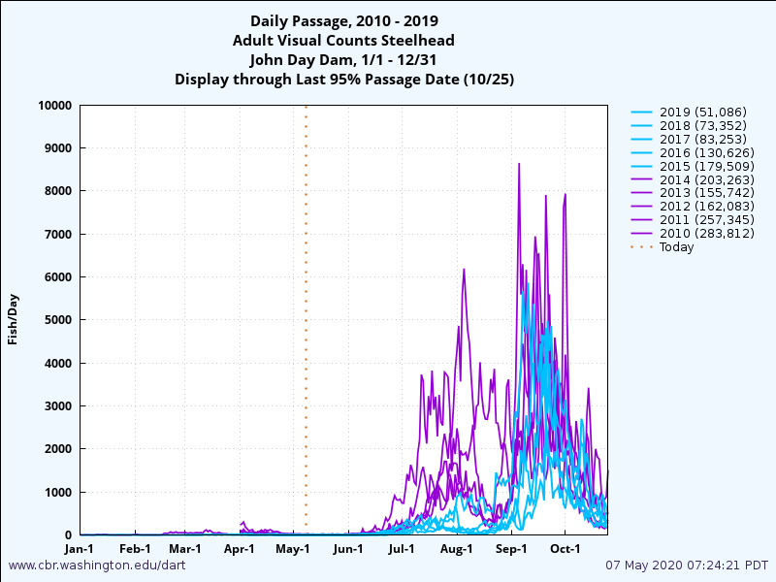
Impacts to juvenile salmon are expected to be minimal if unit priority is affected by a loss of a unit high in the priority order. The majority of the sub-yearling chinook run have past John Day by August.

Adult Steelhead and Chinook passage is low in August for both species at John Day. A deviation from the unit priority should have very little impact on adult passage.

Summary statement - expected impacts on:

Downstream migrants – If there are no problems with the installed submerged traveling screens, there will be no impact to downstream migration. The STS system will be set up to support downstream fish passage as expected during the maintenance period. If problems occur with any submerged traveling screens, the corresponding units will need to be shut down to protect downstream migration.

Upstream migrants (including Bull Trout) - None

Lamprey - None

Comments from agencies

Final coordination results

After Action update (After action statement stating what the effect of the action was on listed species. This statement could simply state that the MOC analysis was correct and the action went as expected, or it could explain how the actual action changed the expected effect (e.g., you didn’t need to close that AWS valve after all, so there was no impact of the action). List any actual mortality noted as a result of the action)

Please email or call with questions or concerns.
Thank you,
Erin

Erin Kovalchuk
NWP Operations Division Fishery Section
Columbia River Coordination Biologist
Erin.H.Kovalchuk@usace.army.mil

